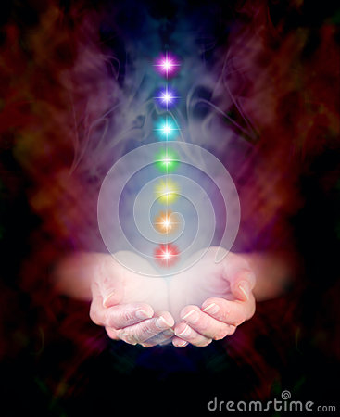
Crystal Healing
£35 1 hour session
Including consultation

What is crystal healing?
By placing crystals on or around a fully clothed person we are able to release stress and pain and induce deep relaxation. The crystals are placed on chakra points and/or including meridian points as used in acupuncture. Meridians are a set of pathways in the body along which vital energy is said to flow. A crystal healing session takes one hour including a consultation.
Crystals can be used to treat:
- Headaches/migraines
- Insomnia
- Stomach, liver and throat issues
- Lack of energy
- Addictions i.e stop smoking
- Joint pain
And much much more!
Crystals can balance our energies, attract positive energy and clear out negative energies.
Feedback from clients after one session
“ I’m not waking up in the night and wheezing like I was, I’m not using my inhaler as much” Susan Dhillion.
For more information or to book a session contact Tracy Gower on 07503998890/tracy22cat@hotmail.co.uk

